DBMS – PRODUCT AND CATEGORY MANAGEMENT
Project Title: Stylecart E-Commerce Database

1.Database Design
Category Table:
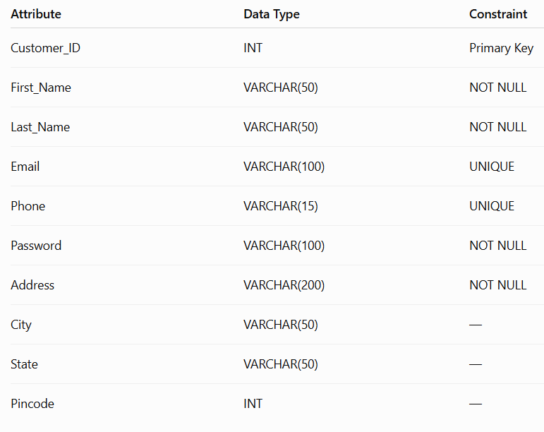

Product table:
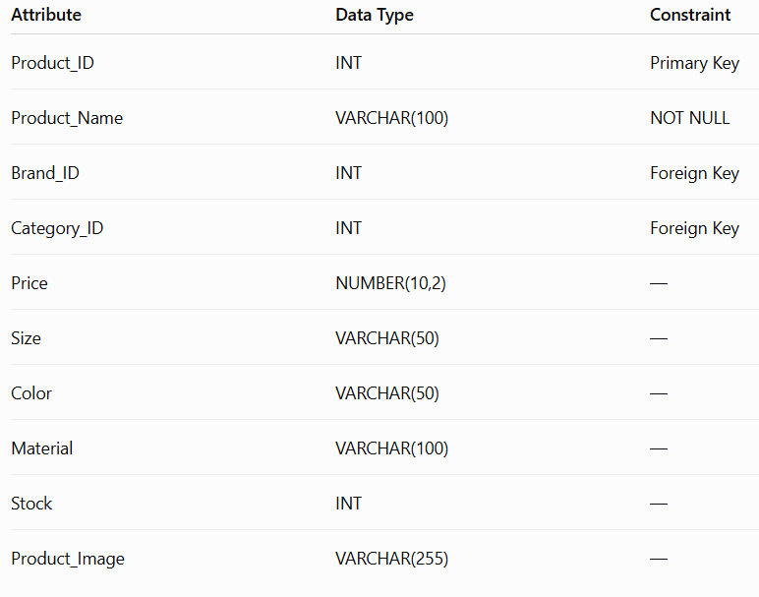
Primary and Foreign Key Relationship:
- Category.Category_ID → Primary Key
- Product.Product_ID → Primary Key
- Product.Category_ID → Foreign Key referencing Category.Category_ID
- Relationship: One-to-Many (1:M)

Table Creation:
Create Category Table:
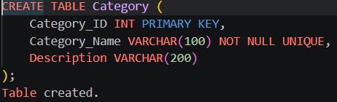
Create Product Table:
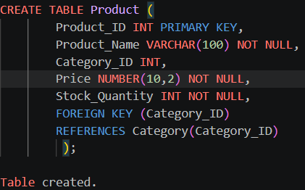

Data Insertion:
Category Record
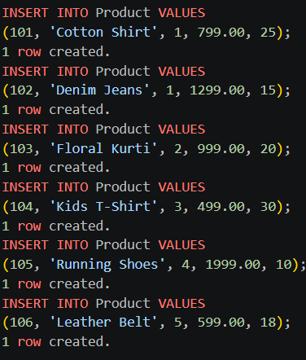
Product Record:
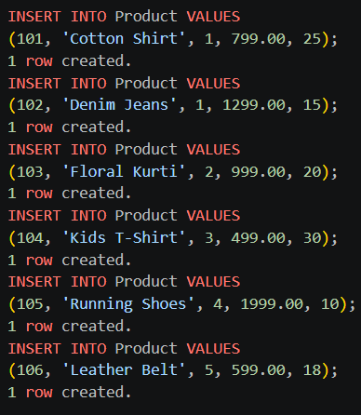

Data reterival :
Display Category Records:
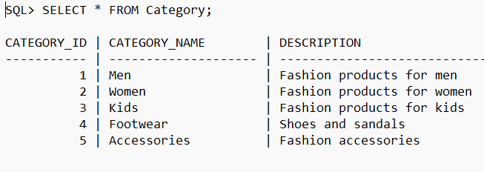
Product Update:
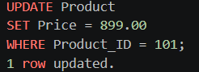
Product Deletion:
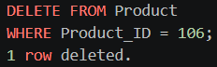
Category-wise Product Reports:
Product by Listing by Category:
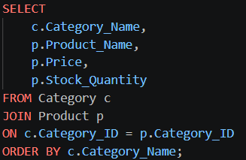
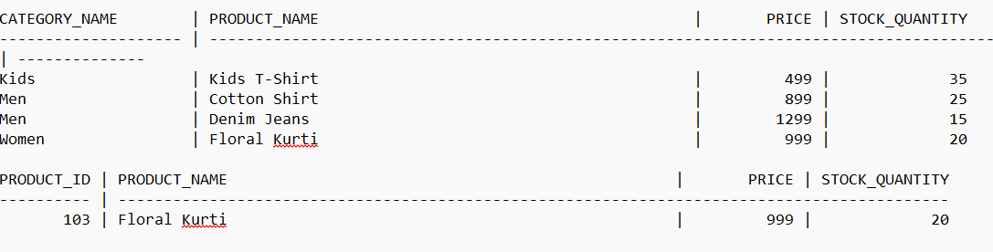

Product in Spices Category:
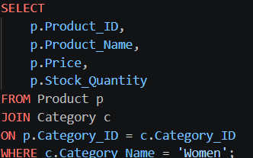
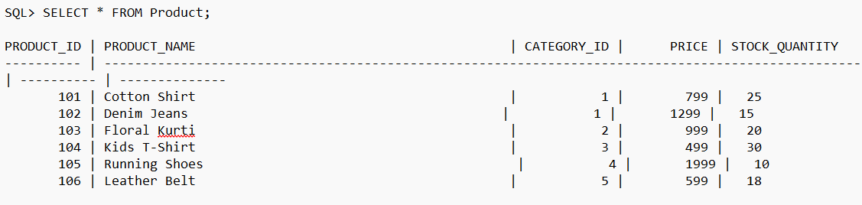
Product Count by Category:
